Jupiter in 2009: Interim Report, with new insights into the NTZ disturbance, NEB expansion, and SEB fading

by John H. Rogers (British Astronomical Association),
using data from the JUPOS team (Hans-Joerg Mettig & colleagues).
[2010 July]

FIGURE LEGENDS AND THUMBNAILS

Copyright notice: All images are copyright to the observers, and JUPOS charts to the JUPOS team. Compilations are copyright to JHR and/or the map-makers credited. If you wish to reproduce anything in any form, or to use data herein, please contact <jhr11@cam.ac.uk>.

South is up in all images and maps.

JUPOS charts show longitude versus time for spots in designated latitude ranges. Black points indicate dark spots, red points indicate bright spots.

Full-size versions of the figures are in the attached Zip file.

___________________________________________________________________________

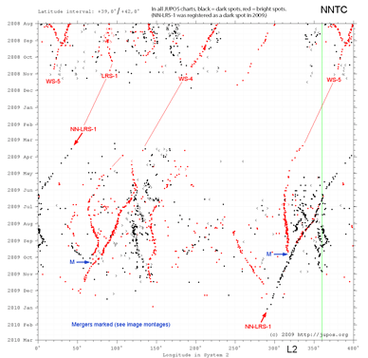

Fig.1. JUPOS chart of longitude versus time for spots in the NNTZ (lats.+39 to +42 N), 2008-2009. In all JUPOS charts, black points indicate dark spots, red points indicate bright spots. LRS-1, WS-4, and WS-5, are long-lived anticyclonic ovals described in Ref.1.

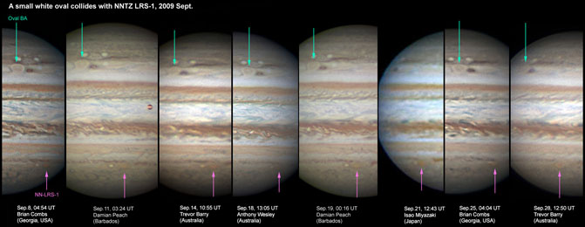

Fig.2. Hi-res images of two long-lived anticyclonic ovals: Oval BA (with only a hint of reddish colour this year) and NN-LRS-1 (exceptionally dark red this year). This sequence shows a smaller AWO (WS5, tracked since 2006) approaching and merging with NN-LRS-1. Compare with a previous such merger shown in Ref.2. Also see Fig.17.

Fig. 3 (below left). Correlation of latitude with speed for the ovals in the NNTZ, prepared by Gianluigi Adamoli from the JUPOS data for 2009, as in Ref.1. All points fit a single gradient just 0.2 deg. S of the wind profile established by Cassini [Porco et al., 2003]; this difference is within the range of systematic errors in either data set. The points are also consistent with the separate parallel gradients for different size classes of ovals, established in previous years [ref.1] (faint lines in matching colours), although data from a single year are not sufficient to confirm these.
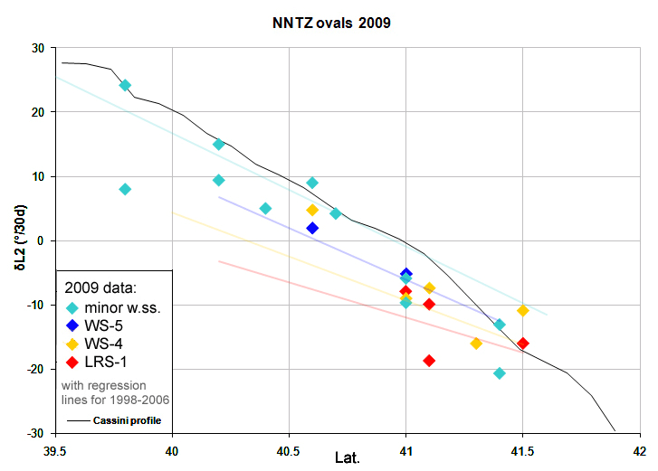

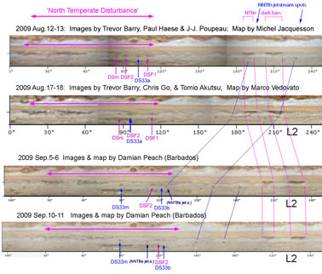

Fig.4. Maps of the N. Temperate region, including the NTD and the pair of very dark bars in NTBn. Each map extends from NEBn to NNTZ. Names of spots
are provisional; see Ref. 8 for final version.

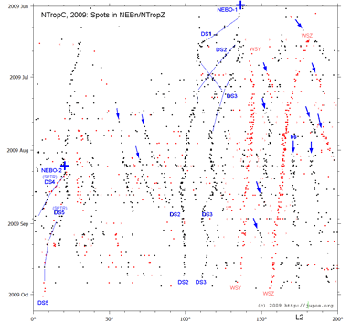
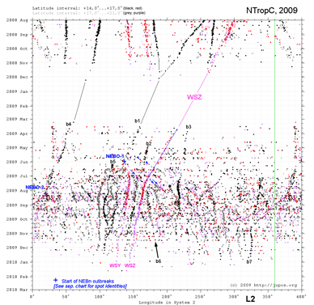

Fig.5a (L). JUPOS chart of the N. Tropical Region (lats.14-21 N). Dark barges are provisionally named b1 to b7.
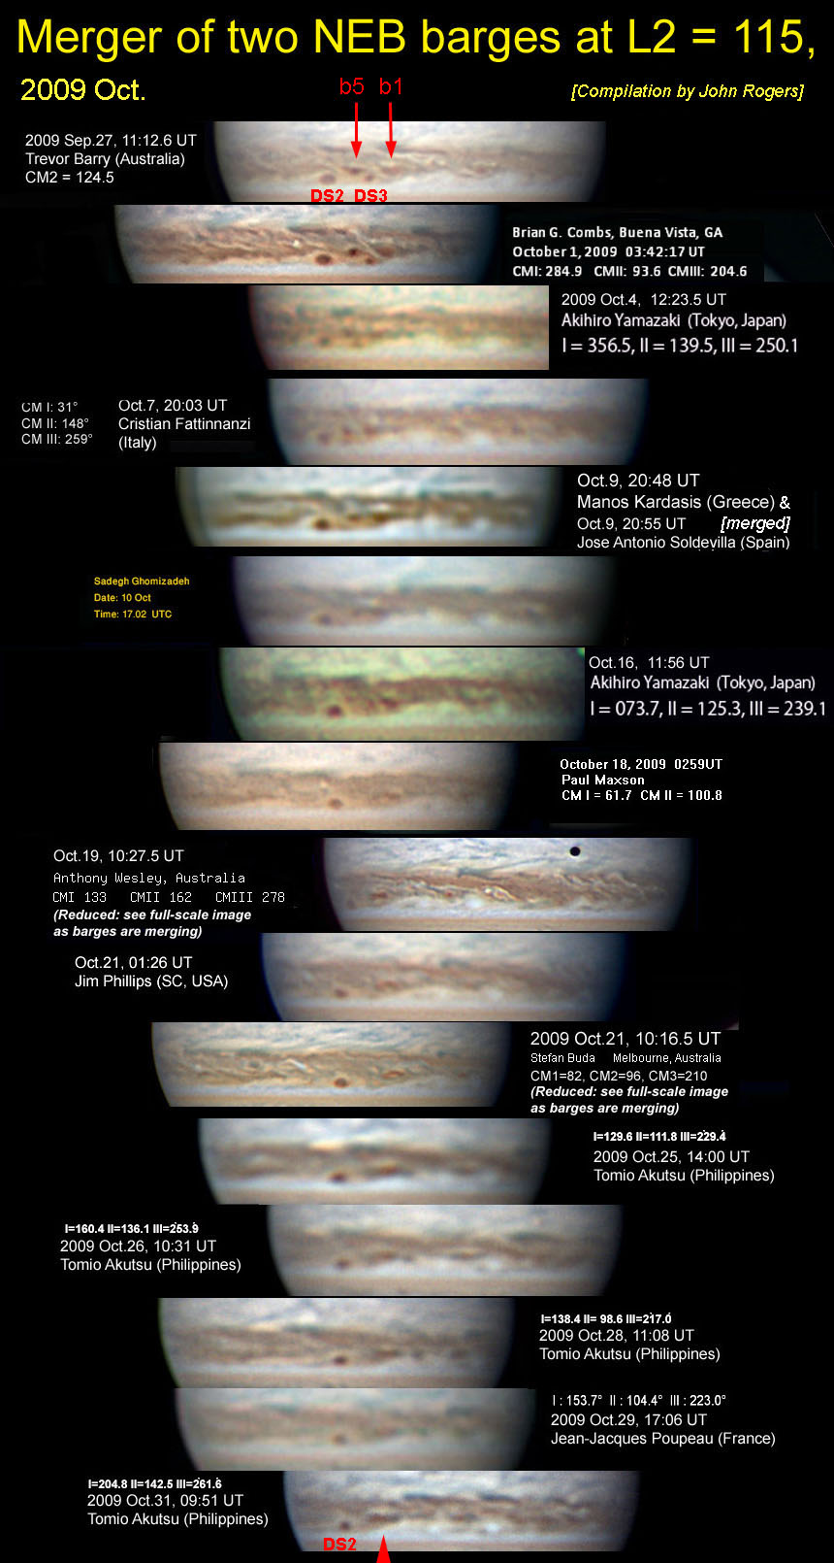
Fig.5b (R). Enlargement of part of the JUPOS chart, covering only NEBn/NTropZ, to show the spots that appeared in the NEBn outbreaks (also see Refs.3 & 4). Retrograding dark spots in NEBn are also shown (blue arrows). This chart, and other charts of the outbreaks, were produced by Michel Jacquesson and Gianluigi Adamoli.

Fig.6. Merger of two NEB barges, at L2 = 115, 2009 Oct. As they came into contact (Oct.14-18), the p. barge (b5) became small and a light spot developed N of them where DS3 had been – a phenomenon not seen in previous barge mergers. On Oct.21, dark material of the merging barges appeared to be flowing cyclonically around this light spot. By Oct.25, they had merged into a single larger brown barge.
(For another recent example of merger of NEB barges, see Ref.2.)

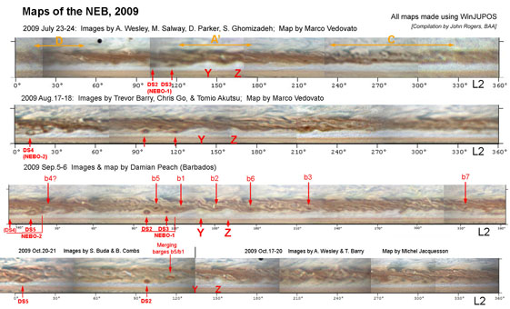
Fig.7. Maps of the NEB, 2009 July to October. Barges, white spots, and spots from the NEBn outbreaks, are labelled in red. On the July map, the expanding NEB rift systems are labelled in orange (A’ and D being later elaborations from rifts A and C respectively).

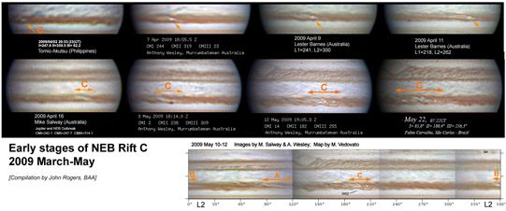

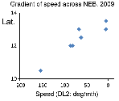
Fig.8. Early views of NEB Rift C, first recorded around March 21, which later expanded to encompass most of the NEB.

Fig.9. Gradient of speed across the NEB, 2009. This graph shows estimates of the speed and latitude of the major rift systems A to D, from JUPOS charts.
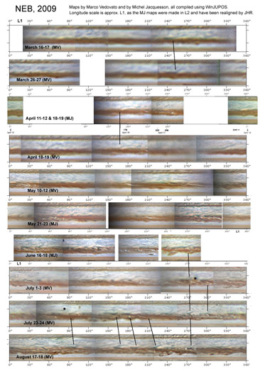

Fig.10. Maps of the NEB and EZ, 2009 March to August. (See Fig.7 for later maps of the NEB.) Maps made by Marco Vedovato and Michel Jacquesson, using images by numerous observers.
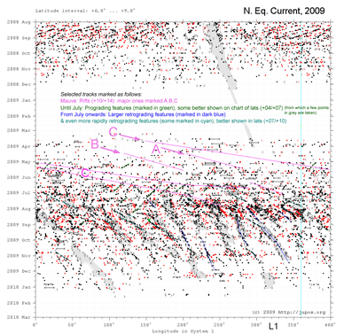

Fig.11. JUPOS chart of the NEBs (lats.6-9 N). Tracks of the major rifts have been overlaid in mauve. The more persistent dark spots and projections are highlighted; however, all of them are more variable and transient than usual.

[Fig.12a is on next page]

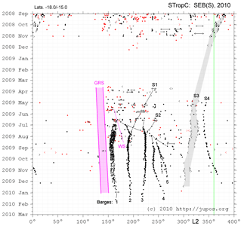
Fig.12b. JUPOS chart of the SEB(S) (lats.18-15 S), showing the pre-existing red streaks S1 to S4, and the formation of barges B1 to B5 in order of increasing longitude.

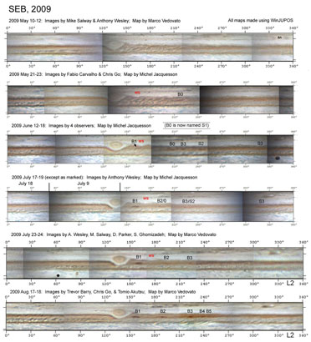

Fig.12a. Maps of the SEB, 2009 May to August, showing the cessation of turbulent activity f. the GRS, and the formation of the barges (B1 to B5) and merger with pre-existing red streaks (S1 labelled B0; S2), as the SEB begins to fade.

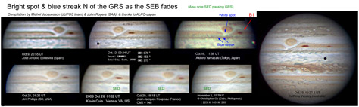

Fig.13. Appearance of a bright spot and blue streak N of the GRS as the SEB fades.

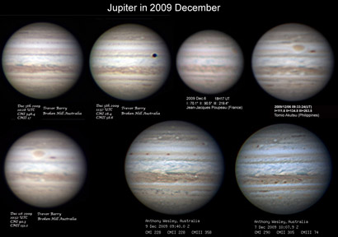

Fig.14a. Set of images all around the planet, 2007 Dec.1-7, showing the state of the planet near the end of the apparition. The fading of the SEB, broadening of the NEB, and darkening of the NTBn, have all proceeded.

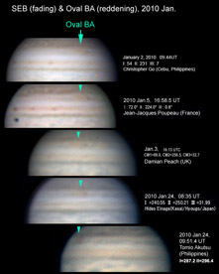
Fig.14b. Images in 2010 Jan., at the end of the apparition, showing oval BA has suddenly reddened again, while the SEB continued to fade.

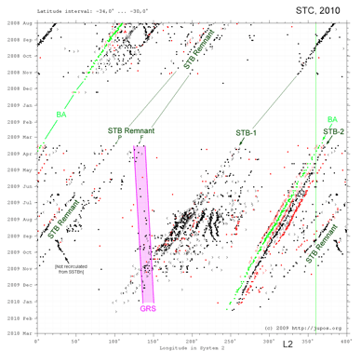

Fig.15. JUPOS chart of S.Temp.Region (lats.30-34 S). Oval BA is plotted in green. The STB Remnant is tracked by the dark cusps that commonly mark its p. and f. ends.

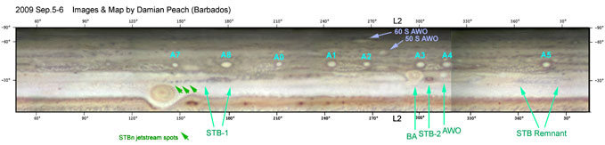

Fig.16. Map of the southern hemisphere on 2009 Sep.5-6, by Damian Peach, with the main spots labelled. Apart from the STB segments, the labelled spots are all anticyclonic ovals.

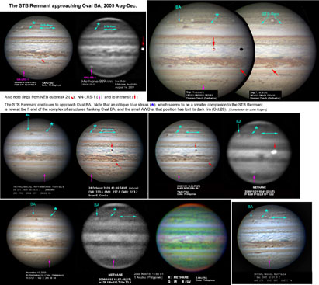

Fig.17. Images showing Oval BA and the STB Remnant approaching it, 2009 Aug-Dec: colour and methane-band images. An oblique blue streak preceding the STB Remnant, which seems to be a smaller but similar disturbance, comes into contact with the small AWO f. oval BA. The STB Remnant and the oblique streak are both methane-dark. Also note the NEB outbreak 2 region, NN-LRS-1, and Io in transit.

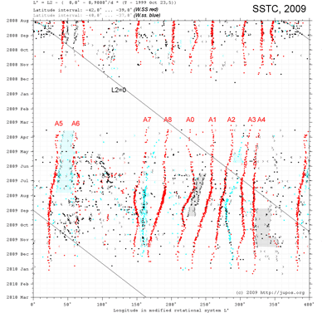
Fig.18. JUPOS chart of the SSTC (lats.37-42 S). The 9 long-lived anticyclonic white ovals (AWOs) are labelled.

